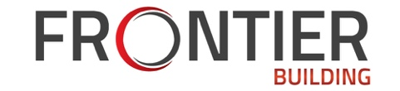
SAFETY VIOLATION NOTICE

Company Name: Date of Violation:
Superintendent Name: Department:
Subcontractor Name: Job Title:

 | 1st Offense |  | 2nd Offense
3rd Offense
Counseling/Retraining Written Reprimand Suspension Termination

The above named Subcontractor was contacted today regarding the following safety violation:

The Subcontractor’s explanation of his/her behavior is the following:

I (the Subcontractor) understand that safety rules and practices are necessary to reduce accidents and injuries on the job. Safe behavior on the job not only protects me, but my fellow workers as well. it is also understood that my employer, by law, must impose disciplinary procedures, which could include termination.

Subcontractor Signature Date
This form is to be filled out by the Superintendent/Supervisor and the Subcontractor. The form will be maintained in the Subcontractor’s file for two years.

Superintendent Signature Date

